**English**

**Cinderella of the Nile – cont.**

* **Descriptions**
* **Letters**
* **Discussions**
* **Own narrative**

**Cloud Tea Monkeys**

**- Non chronological reports**

**- Descriptions**

**- Instructions**

**- Letters**

**- Discussions**

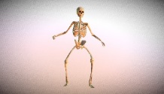

[This Photo](https://sketchfab.com/3d-models/skeleton-animated-9210377c7a514cf6b48a31b9d3991ff3) by Unknown Author is licensed under [CC BY](https://creativecommons.org/licenses/by/3.0/)

**Science**

**Animals including humans**

* **Skeleton**
* **Muscles and bones**
* **Comparing skeletons**

**Plants**

**-function of different parts**

**-life cycle of pollination, seed formation, dispersal and germination.**

**-drawing and labelling**

**Maths**

**Mass and Capacity**

**-Using scales**

**-Measure in grams/kilograms**

**-add/subtract mass**

**-measure capacity and volume**

**-add/subtract/compare**

**Fractions**

* **Addition**
* **Subtraction**
* **Partitioning**
* **Finding amounts using unit and non unit fractions**

**Time**

* **O’clock, half past, quarter to and quarter past**
* **Months, years, hours in a day**
* **Telling the time to 5 minutes, a.m and p.m**
* **24 Hour Clock.**

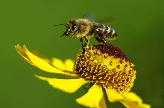

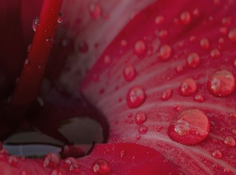

**Art**

* **Georgia O’Keefe**
* **Sketches**
* **First hand observation**
* **Water colours**

**RE**

**Called by God**

* **What does it mean?**
* **How does God speak to people?**

**PSHE - Being My Best**

**- Healthy Eating**

**- Body Team Work**

**- For and Against**

**- I am Fantastic**

**- Top Talents**



**Half Termly Homework**

Producing a piece of ‘Flower Art’ – link to Georgia O’Keefe Art



Year 3

Summer Term 1

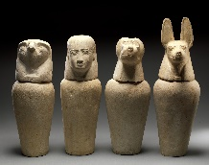

**PE-Lancashire Scheme of Work**

**Outdoor and Adventurous Activities**

**– Trust and Trails**

**Net/Wall Games**

**-throwing and catching**

**-striking a ball**

**Computing**

**Programming B- Events and actions in a program.**

**-moving a sprite**

**-maze movement**

**-drawing lines**

**-adding features**

**-debugging movement**

**-making a project**

**Music**

**Charanga Scheme Of Work Activities -glockenspiel**

**History - cont**

**-The Nile and its importance**

**-Culture and Religion**

**-Inventions/Hieroglyphics**

**-Mummification**

**-Pyramids Tombs.**

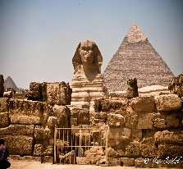

[This Photo](http://marc1987.deviantart.com/art/the-pyramids-of-giza-4-177385603) by Unknown Author is licensed under [CC BY-SA-NC](https://creativecommons.org/licenses/by-nc-sa/3.0/)

**French**

* **Parts of the body**
* **Numbers 21-30**